

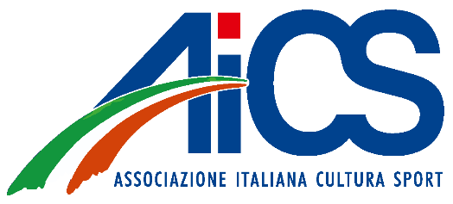

**Parental Consent Form**

**Permission to participate in** **World Pole Sport and Aerial Sport 2024**

I, the undersigned, certify that I am the parent or legal guardian of the below mentioned Participant.

I hereby authorize my minor child named bellow to participate in the **World Pole Sport and Aerial Sport 2024** Competition.

|  |  |
| --- | --- |
| Full name of child |  |
| Birth date of child: |  |
| Parent’s/Guardian Name |  |
| Contact e-mail address or telephone number |  |

I confirm that by completing this form, I have read, understood and agreed to the rules of the Competition. I confirm that ______________________________________________________(name of the coach) is the person who will supervise and accompany my child in all official competition and warm-up areas.

I acknowledge and understand that my child’s participation in this sport activity have certain risks associated with it. I agree to assume these risk. I confirm that I well informed about all the details of the event.

Signature of Parent or Legal Guardian Date